
Name: _____________ Date: _________

Logic Flow Charts
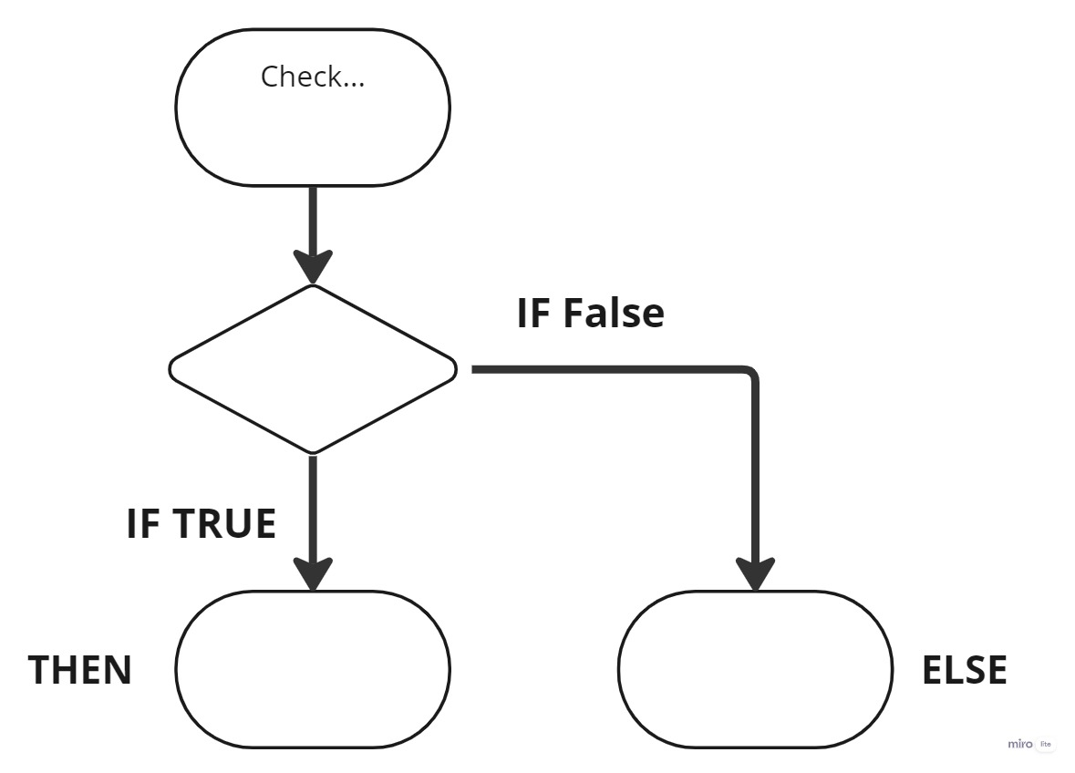
Complete the flow charts with a logic selection from daily life.

1

2
If you finish, write the IF, THEN, ELSE statements on the back.

Name: _____________ Date: _________

Logic Flow Charts
Complete the flow charts with a logic selection from daily life.

1

2
If you finish, write the IF, THEN, ELSE statements on the back.

