Rotate the screen LED planning sheet – Remember your image should look the same when you turn your micro:bit
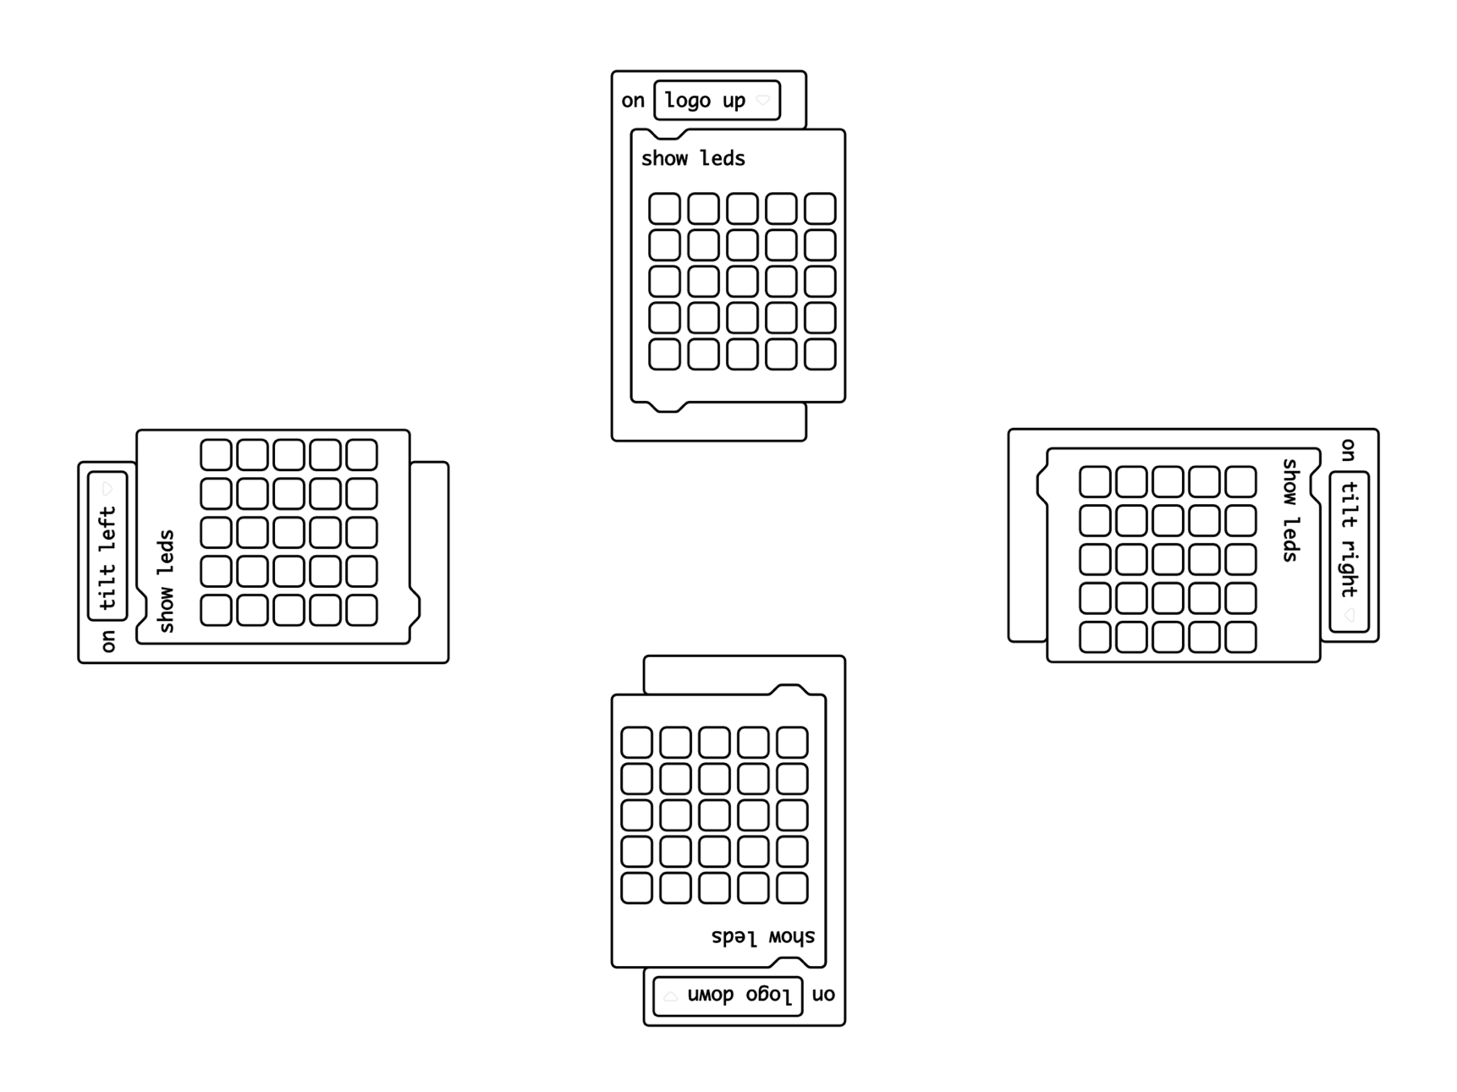
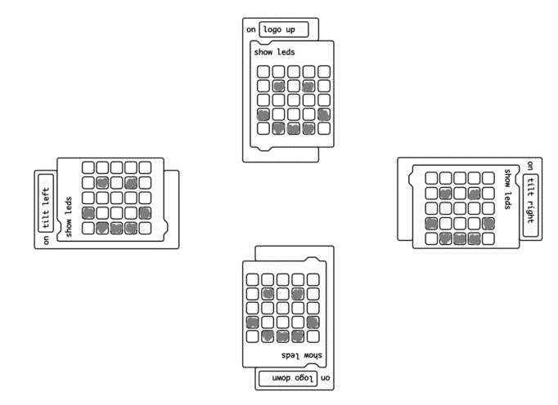
Name:
Example:

